**Class** **Diagram**: Showing the main classes of the given system.

* **Class**: Manager, Employee, Accountant, Technical Support, Customer, Advertiser, Payment, Flat||Plot
* **Attribute**:

Manager: m_id, m_name, m_salary, m_phoneNumber, e_id(fk)

Employee: e_id**,** e_name, e_salary, e_address, e_phnumber, m_id(fk)

Accountant: a_id, a_name, a_salary, a_phnumber, m_id(fk

Customer: c_id, c_name, c_adress, c_phnumber, c_occupation, c_age, c_nationality,

t_id(fk), a_id(fk), p_id(fk)

Technical Support: t_id**,** t_name, t_salary, t_phnumber, c_id(fk)

Advertiser: adv_id**,** adv_name, adv_salary, adv_phnumber, adv_region, fp_id(fk)

Payment: p_id, p_name, p_amount, p_date, c_id(fk), m_id(fk)

Flat||Plot: fp_id, fp_name, fp_price, fp_phnumber, fp_region, adv_id(fk)

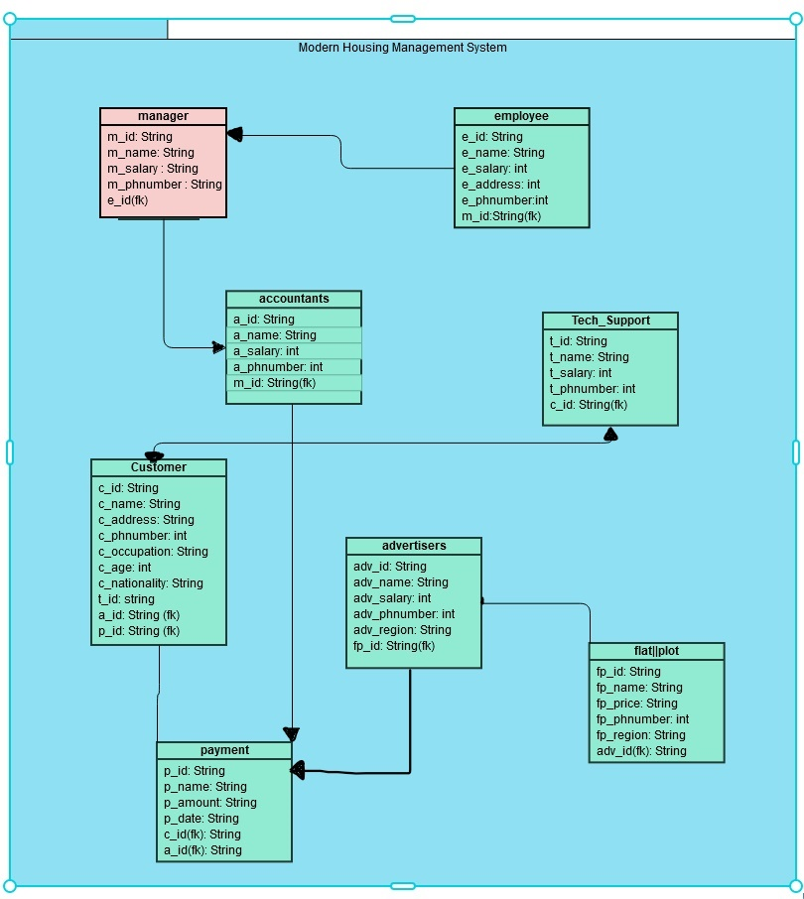

**Fig: Class Diagram**